COVID-19
Safeguarding and Child Protection Arrangements

Withinfields Primary School

School Name: Withinfields Primary School
Policy owner: Helen York
Date: 1st April 2020
Date shared with staff: 1st April 2020

Context

From 20th March 2020 parents were asked to keep their children at home, wherever possible, and for schools to remain open only for those children of workers critical to the COVID-19 response - who absolutely need to attend.

Schools and all childcare providers were asked to provide care for a limited number of children - children who are vulnerable, and children whose parents are critical to the COVID-19 response and cannot be safely cared for at home.

This addendum of the Withinfields’ safeguarding policy and child protection procedures contains details of our individual safeguarding arrangements in the following areas:

Table of contents Page

- Contacts…………………………………………………………………………… ….……2

- Vulnerable children…………………………………………………………………….…..3

- Attendance monitoring…………………………………………………………….……..4

- Designated Safeguarding Lead………………………………………………………...5

- Reporting a concern………………………………………………………………….…….5

- Safeguarding training and induction…………………………………………….…..6

- Safer Recruitment, volunteers and movement of staff…………………….….7

- Online safety in schools and colleges…………………………………………….….8

- Children and online safety away from school and college....……………….8

- Supporting children not in school……………………………………………………..9

- Supporting children in school…………………………………………………………..9

- Peer on Peer abuse………………………………………………………………………..10

- Supervision support for school safeguarding staff………………………….….10

- School Hubs – Additional information………………………………………….…..11

- Key contacts

Role | Name | Contact number | Email
Designated Safeguarding Lead | Jane Lowerson | 01422 363581 option 6 | Jane.lowerson@withinfields.calderdale.sch.uk
Deputy Designated Safeguarding Leads | Sian Barton | 01422 363581 option 6 | sian.barton@withinfields.calderdale.sch.uk
Headteacher | Helen York | 01422 363581 option 6 | Helen.york@withinfields.calderdale.sch.uk
Chair of Governors | Victoria Percival | 01422 363581 option 6 | admin@withinfields.calderdale.sch.uk
Safeguarding Governor | Wendy Moffatt | 01422 363581 option 6 | admin@withinfields.calderdale.sch.uk

Vulnerable children

Vulnerable children include those who have a social worker and those children and young people up to the age of 25 with education, health and care (EHC) plans.

Those who have a social worker include children who have a Child Protection Plan and those who are looked after by the Local Authority. A child may also be deemed to be vulnerable if they have been assessed as being in need or otherwise meet the definition in section 17 of the Children Act 1989 (Child in Need)

Those with an EHC plan will be risk-assessed in consultation with the Local Authority and parents, to decide whether they need to continue to be offered a school or college place in order to meet their needs, or whether they can safely have their needs met at home. This could include, if necessary, carers, therapists or clinicians visiting the home to provide any essential services. Many children and young people with EHC plans can safely remain at home.

Eligibility for free school meals in and of itself should not be the determining factor in assessing vulnerability.

Senior leaders, especially the Designated Safeguarding Lead (and deputy) know who our most vulnerable children are. They have the flexibility to offer a place to those on the edge of receiving children’s social care support.

Withinfields Primary School will continue to work with and support children’s social workers to help protect vulnerable children. This includes working with and supporting children’s social workers and the local authority virtual school head (VSH) for looked-after and previously looked-after children. The lead person for this will be: Jane Lowerson

There is an expectation that vulnerable children who have a social worker will attend an education setting where the risk assessment determined they would be safer to do so. In circumstances where a parent does not want to bring their child to an education setting, and their child is considered vulnerable, the social worker and Withinfields’ staff will explore the reasons for this directly with the parent.

Where parents are concerned about the risk of the child contracting COVID19, Withinfields’ staff or the social worker will talk through these anxieties with the parent/carer following the advice set out by Public Health England.

Withinfields Primary School will encourage our vulnerable children and young people to attend a school, including remotely if needed.

Attendance monitoring

Local authorities and education settings do not need to complete their usual day-to-day attendance processes to follow up on non-attendance.

If Withinfields has any children in attendance (e.g. because they are vulnerable or their parent(s) / carers are critical workers) we will submit the daily attendance sheet to the DfE by 12 noon - https://www.gov.uk/government/publications/coronavirus-covid-19-attendance-recording-for-educational-settings

We will also forward such attendance figures to Calderdale Children’s services using the email address: MASTAdmin@calderdale.gov.uk and the School Effectiveness Service if required at: https://forms.gle/hFEt2f27GDc6j8Fg6

If the school has closed, we will complete the return once as requested by the DfE.

‘Nil’ returns will still be collated by Calderdale Children’s Services.

Withinfields’ staff and social workers will agree with parents/carers whether children in need should be attending school – Withinfields Primary School will then follow up on any pupil that they were expecting to attend, who does not. Withinfields’ staff will also follow up with any parent or carer who has arranged care for their child(ren) and the child(ren) subsequently do not attend.

To support the above, Withinfields’ staff will, when communicating with parents/carers and carers, confirm emergency contact numbers are correct and ask for any additional emergency contact numbers where they are available.

In all circumstances where a vulnerable child does not take up their place at school, or discontinues, Withinfields Primary school will notify their social worker via: MASTAdmin@calderdale.gov.uk

Designated Safeguarding Lead

Withinfields Primary School has a Designated Safeguarding Lead (DSL) and Deputy DSLs.

The Designated Safeguarding Lead is: Jane Lowerson

The Deputy Designated Safeguarding Leads are: Helen York, Sian Barton and Jo Parkin.

The optimal scenario is to have a trained DSL (or deputy) available on site. Where this is not the case a trained DSL (or deputy) will be available to be contacted via phone or online video - for example when working from home.

Where a trained DSL (or deputy) is not on site, in addition to the above, a senior leader will assume responsibility for co-ordinating safeguarding on site.

This might include updating and managing access to child protection online management system, CPOMS (or individual pupil safeguarding file) and liaising with the offsite DSL (or deputy) and as required liaising with children’s social workers where they require access to children in need and/or to carry out statutory assessments at the school or college.

It is important that all Withinfields’ staff and volunteers have access to a trained DSL (or deputy). On each day, the staff on site will be made aware of who that person is and how to contact them.

The DSL will continue to engage with social workers, and attend all multi-agency meetings, which can be done remotely.

Reporting a concern

Where staff have a concern about a child, they should continue to follow the process outlined in the substantive school Safeguarding Policy, this includes the recording of a report via CPOMS, which can be done remotely.

In the event that a member of staff cannot access their CPOMS from home, they should email their concern/report to the Designated Safeguarding Lead or Deputy Designated Safeguarding Lead. This will ensure that the concern is received and reviewed in accordance with national safeguarding guidance.

Staff are reminded of the need to report any concern immediately and without delay.

Where staff are concerned about an adult working with children in the school, they should report their concern to the headteacher. If there is a requirement to make a notification to the headteacher whilst away from school, this should be done verbally and followed up with an email to the headteacher.

Concerns around the Headteacher should be directed to the Chair of Governors: Victoria Percival via the school admin email address – admin@withinfields.calderdale.sch.uk. Please call the email “Confidential – FAO Victoria Percival”

Concerns about any adult working with children should be referred to the Local Authority Designated Officer for Child Protection (LADO)
Email: LADOAdmin@calderdale.gov.uk (This is a secure email address)

The school HR provider may assist in the managing allegations process.

Safeguarding Training and induction

DSL training is very unlikely to take place whilst there remains a threat of the COVID 19 virus.

For the period COVID-19 measures are in place, a DSL (or deputy) who has been trained will continue to be classed as a trained DSL (or deputy) even if they miss their refresher training date.

All existing school staff have had safeguarding training and have read part 1 of Keeping Children Safe in Education (2019).
The DSL should communicate with staff any new local arrangements, so they know what to do if they are worried about a child.

School will continue to provide safeguarding induction training for all new staff and volunteers.

If staff are deployed from another education or children’s workforce setting to our school, we will take into account the DfE supplementary guidance on safeguarding children during the COVID-19 pandemic and will accept portability of safer recruitment checks as long as the current employer confirms in writing that:-

- the individual has been subject to an enhanced DBS and children’s barred list check

- there are no known concerns about the individual’s suitability to work with children

- there is no ongoing disciplinary investigation relating to that individual

Upon arrival, they will be given a copy of the receiving setting’s child protection policy, confirmation of local processes and confirmation of DSL arrangements.

Safer recruitment/volunteers and movement of staff

It remains essential that people who are unsuitable are not allowed to enter the children’s workforce or gain access to children. When recruiting new staff, Withinfields Primary School will continue to follow the relevant safer recruitment processes for their setting, including, as appropriate, relevant sections in part 3 of Keeping Children Safe in Education (2019) (KCSIE).

In response to COVID-19, the Disclosure and Barring Service (DBS) has made changes to its guidance on standard and enhanced DBS ID checking to minimise the need for face-to-face contact.

If staff are deployed from another education or children’s workforce setting to our school, we will take into account the DfE supplementary guidance on safeguarding children during the COVID-19 pandemic and will accept portability as long as the current employer confirms in writing that:-

- the individual has been subject to an enhanced DBS and children’s barred list check

- there are no known concerns about the individual’s suitability to work with children

- there is no ongoing disciplinary investigation relating to that individual

Where Withinfields Primary School are utilising volunteers, we will continue to follow the checking and risk assessment process as set out in paragraphs 167 to 172 of KCSIE. Under no circumstances will a volunteer who has not been checked be left unsupervised or allowed to work in regulated activity.

Withinfields Primary School will continue to follow the legal duty to refer to the DBS anyone who has harmed or poses a risk of harm to a child or vulnerable adult. Full details can be found at paragraph 163 of KCSIE 2019.

Withinfields Primary School will continue to consider and make referrals to the Teaching Regulation Agency (TRA) as per paragraph 166 of KCSIE 2019 and the TRA’s ‘Teacher misconduct advice for making a referral.

During the COVID-19 period all referrals should be made by emailing Misconduct.Teacher@education.gov.uk

Whilst acknowledging the challenge of the current National emergency, it is essential from a safeguarding perspective that any school is aware, on any given day, which staff/volunteers will be in the school or college, and that appropriate checks have been carried out, especially for anyone engaging in regulated activity. As such, Withinfields Primary School will continue to keep the single central record (SCR) up to date as outlined in paragraphs 148 to 156 in KCSIE 2019.

Online safety in schools and colleges

Withinfields Primary School will continue to provide a safe environment, including online. This includes the use of an online filtering system.

Where students are using computers in school, appropriate supervision will be in place. This supervision may include the use of electronic monitoring systems that alert school leaders to inappropriate use of computer related equipment.

Staff and pupils will be expected to follow the school’s online safety policy.

Children and online safety away from school and college

It is important that all staff who interact with children, including online, continue to look out for signs a child may be at risk. Any such concerns should be dealt with as per the Child Protection Policy and where appropriate referrals should still be made to children’s social care and as required, the police.

Online teaching should follow the same principles as set out in out in the school code of conduct.

Withinfields Primary School will ensure any use of online learning tools and systems is in line with privacy and data protection/GDPR requirements.

Below are some things to consider when delivering virtual lessons, especially where webcams are involved:

- No 1:1s, groups only
- Staff and children must wear suitable clothing, as should anyone else in the household.
- Any computers used should be in appropriate areas, for example, not in bedrooms; and the background should be blurred.
- The live class should be recorded so that if any issues were to arise, the video can be reviewed.
- Live classes should be kept to a reasonable length of time, or the streaming may prevent the family ‘getting on’ with their day.
- Language must be professional and appropriate, including any family members in the background.
- Staff must only use platforms specified by senior managers and approved by our IT network manager / provider to communicate with pupils
- Staff should record, the length, time, date and attendance of any sessions held.

Supporting children not in school

Withinfields Primary School is committed to ensuring the safety and wellbeing of all its children and young people.

Where the DSL has identified a child to be on the edge of social care support, or who would normally receive pastoral-type support in school, we will try and ensure that a robust communication plan is in place for that child or young person.

Details of this communication plan will be recorded on CPOMS, (or individual pupil safeguarding file) as should a record of contacts that have made.

The communication plans can include; remote contact, phone contact, text contact. Other alternative individualised contact methods should be considered and recorded.

Withinfields Primary School and its DSL will work closely with all stakeholders to maximise the effectiveness of any communication plan.

It is recommended that in the main, vulnerable pupils are contacted twice weekly unless additional measures become necessary which will be agreed in conjunction with a social worker.

This plan will be reviewed regularly (at least once a fortnight) and where concerns arise, the DSL will consider whether any referrals to MAST or other agencies for support may be necessary.

Where school cannot establish contact with vulnerable pupils and their families, it is important to ensure this situation is passed to the MAST team using email address: MASTAdmin@calderdale.gov.uk

The school will share safeguarding messages on its website and social media pages.

Withinfields Primary School recognises that school is a protective factor for children and young people, and the current circumstances, can affect the mental health of pupils and their parents/carers. Teachers at Withinfields Primary School need to be aware of this in setting expectations of pupils’ work where they are at home.

Supporting children in school

Withinfields Primary School is committed to ensuring the safety and wellbeing of all its students.

Withinfields Primary School will continue to be a safe space for all children to attend and flourish. The Headteacher will ensure that appropriate staff are on site and staff to pupil ratio numbers are appropriate, to maximise safety.

Withinfields Primary School will refer to the latest Government guidance for education and childcare settings on how to implement social distancing and continue to follow the advice from Public Health England on handwashing and other measures to limit the risk of spread of COVID19.

Withinfields Primary School will ensure that where we care for children of critical workers and vulnerable children on site, we ensure appropriate support is in place for them. This will be bespoke to each child and recorded on CPOMS (or individual pupil safeguarding file).

Where it is necessary to provide personal and/or intimate care in respect of a child, school will follow their substantive personal and intimate care policy including making a record of the nature/time/date and staff involved in respect of care provided.

School leaders will monitor the impact of any staff absence, in particular the posts of Designated Safeguarding Leads and first aid trained staff in order to ensure the safe and effective running of the school and take appropriate management action where necessary.

Peer on Peer Abuse

Withinfields Primary School recognises that during the closure a revised process may be required for managing any report of peer on peer abuse and supporting victims.

Where a school receives a report of peer on peer abuse, they will follow the principles as set out in part 5 of KCSIE 2019 and of those outlined within the substantive school safeguarding policy.

The school will listen and work with the young person, parents/carers and any multi-agency partner required to ensure the safety and security of that young person.

Concerns and actions must be recorded on CPOMS and following assessment by the Designated Safeguarding Lead, appropriate referrals made.

Supervision Support for the school safeguarding staff

Governors of the school should ensure that appropriate supervision support is in place for staff engaged in the safeguarding process, in order to carry out their role effectively.

This may include, remotely accessing child safeguarding files for the purpose of quality assurance, support, guidance and direction.

Regular group and individual safeguarding supervision sessions should remain a key factor in ensuring the effectiveness of safeguarding at the school.

- School Hubs – Additional information
This section is provided to assist schools operating under a school hub model with their daily safeguarding processes. These heavily rely upon good relationships, and excellent lines of communication between the Hub school (herein referred to as The Hub) and the supplying school. Each Hub school will have a headteacher responsible for day to day overall management (herein referred to as the Hub Manager)
- A trained Designated Safeguarding Lead and Deputy to be available on site in the Hub. These persons hold the title “Hub DSL and Hub Deputy DSL” Staff holding this role are likely to change throughout the period of operation. Their direct contact details will be provided to supplying schools and be clearly displayed in the Hub.

- All supplying schools to provide email and mobile telephone contact details for an “on call” DSL for their school and be equipped to access CPOMS or alternative recorded child safeguarding file information throughout normal school hours. This person will hold the title “Home DSL”

- All supplying schools DSL contact details to be held securely by the Hub manager for daily use by the allocated Hub DSL and Deputy Hub DSL.

- A brief overview of the safeguarding position around all pupils attending the Hub to be prepared by the Home DSL and sent electronically by email to the Hub DSL.

- This information will be retained by the Hub manager / Hub DSL and the overview must contain full details of all parents/carers, details of any allocated professional working with the child, including social workers, virtual school support staff, therapists, psychologists etc. including mobile telephone contact details and email addresses. It must also contain details of any daily specific requirements such as the provision of medication inc. inhalers / epipens and any specific medical conditions e.g. known allergies/asthma. The Hub will require to know any behavioural management measures that the supplying school have in place.

- The Hub DSL is to email daily attendance information of pupils to the Home DSL, in addition to the requirements set out in section 3.

- Where non-attendance of any pupil becomes a safeguarding concern the Home DSL should make necessary enquiries to establish the current welfare of the pupil following “First Day Calling procedures.”

- All safeguarding concerns identified in the Hub are to be notified by staff with immediate effect to the Hub DSL or Hub Deputy DSL using where appropriate a Child Protection Cause for Concern form – see appendix 1.

- Where any injuries are noted the Hub DSL or Hub Deputy DSL will ensure they are recorded on a Body map. Either on CPOMS or on paper as necessary - See appendix 2 and follow the guidance.

- The Hub DSL will have overall direction of any safeguarding concern identified in the Hub and be responsible for decisions on whether referrals are necessary to Children’s Social care via MAST using 01422 393336 and email:
MASTAdmin@calderdale.gov.uk

- The Hub DSL will link directly with the Home DSL to ensure that all safeguarding information, including new record entries, referrals to MAST, actions undertaken are fully recorded as soon as possible by the Home DSL on their CPOMS system or other recording system.

- Where specific directions from MAST are received, responsibility for carrying out those directions will be discussed between the Hub DSL and Home DSL. The Hub manager will have overall control over any disputed issues.

Appendix 1

Child Protection
Cause for Concern Form

Date: |  | Time:
Name of Child:
Date of Birth: |  | UPN Number:
Reporting Adult: |  | Role:
Reporting Adult Signature: |  | DSL Signature:

Details of Concern (who, what, where, when):

Facts -

Opinions -

DSL Follow up:

Early Intervention Service Manager Contacted for advice Yes/No

Early Intervention Panel Referral Yes/No

MAST Contacted for advice: Yes/No

MAST Referral: Yes/No

Time of contact:

Outcome of contact:

Child’s CASS Number:

Actions:

Review Date:

Appendix 2

Body Map Guidance for Schools

Body Maps should be used to document and illustrate visible signs of harm and physical injuries.

Always use a black pen (never a pencil) and do not use correction fluid or any other eraser.

Do not remove clothing for the purpose of the examination unless the injury site is freely available because of treatment.

*At no time should an individual teacher/member of staff or school take photographic evidence of any injuries or marks to a child’s person, the body map below should be used. Any concerns should be reported and recorded without delay to the appropriate safeguarding services, e.g. MAST or the child’s social worker if already an open case to social care.

When you notice an injury to a child, try to record the following information in respect of each mark identified e.g. red areas, swelling, bruising, cuts, lacerations and wounds, scalds and burns:

- Exact site of injury on the body, e.g. upper outer arm/left cheek.
- Size of injury - in appropriate centimetres or inches.
- Approximate shape of injury, e.g. round/square or straight line.
- Colour of injury - if more than one colour, say so.
- Is the skin broken?
- Is there any swelling at the site of the injury, or elsewhere?
- Is there a scab/any blistering/any bleeding?
- Is the injury clean or is there grit/fluff etc.?
- Is mobility restricted as a result of the injury?
- Does the site of the injury feel hot?
- Does the child feel hot?
- Does the child feel pain?
- Has the child’s body shape changed/are they holding themselves differently?

Importantly the date and time of the recording must be stated as well as the name and designation of the person making the record. Add any further comments as required.

Ensure First Aid is provided where required and then recorded appropriately.

A copy of the body map should be kept on the child’s concern/confidential file.

BODYMAP
(This must be completed at time of observation)

Name of Pupil: |  |  |  | Date of Birth:
Name of Staff: |  |  |  | Job title:
Date and time of observation:

Name of pupil: |  |  | Date and time of observation:
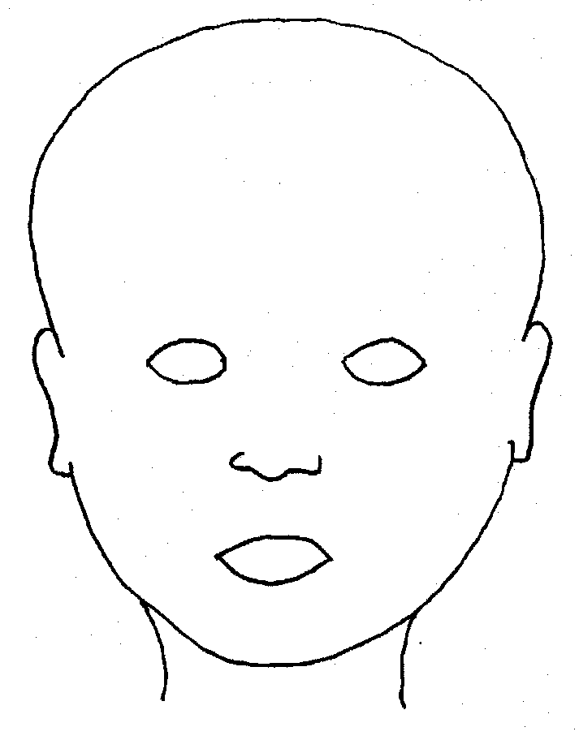
FRONT |  | BACK
 |  | 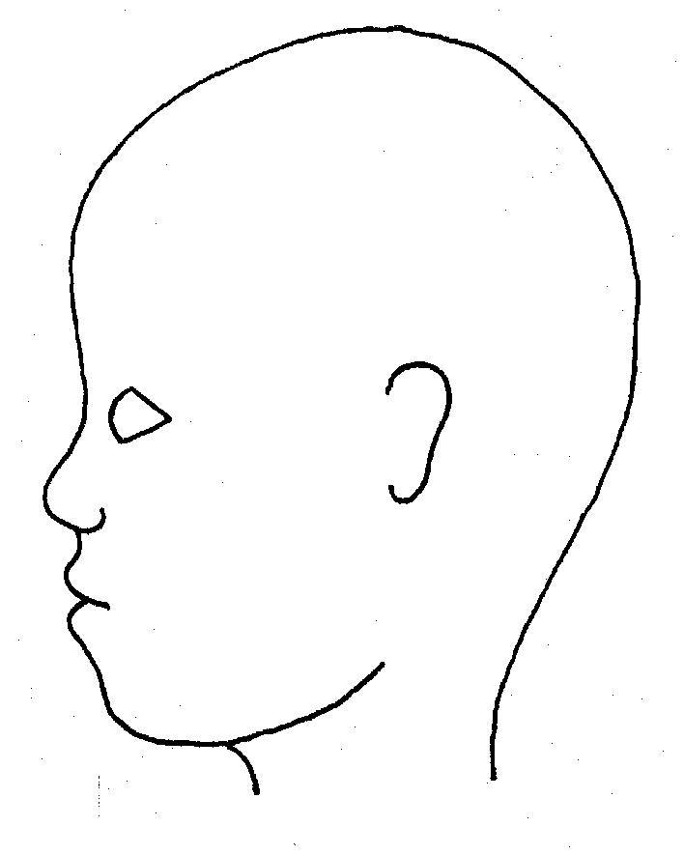
RIGHT |  | LEFT

Name of pupil: |  |  |  |  |  |  | Date and time of observation:
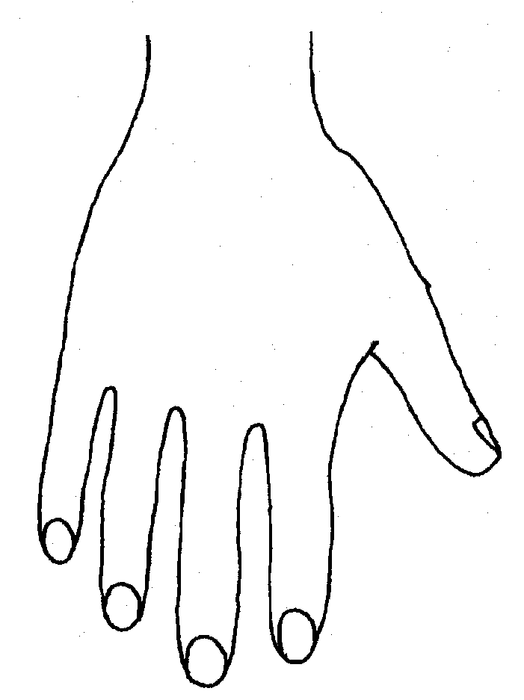 |  |  |  |  |  | 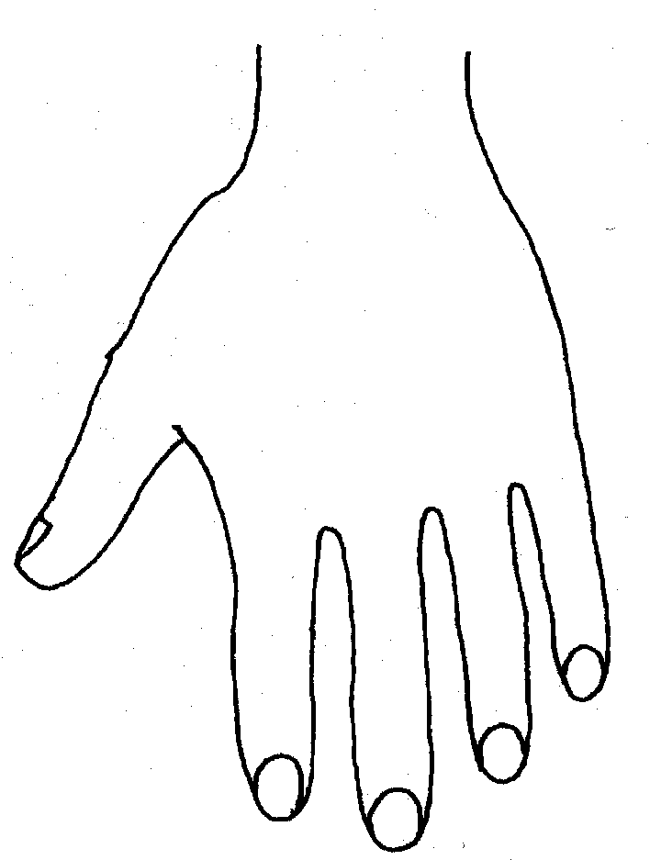
R |  |  |  |  |  | L
BACK
FRONT
Name of Pupil: |  |  |  |  |  |  | Date and time of observation:
R |  | TOP | L |  | R |  |  | BOTTOM |  | L
R |  |  |  |  | L
INNER
R |  |  |  |  | L
OUTER
Name:

Signature:
Job title of staff:

